Département de Génie Informatique et Communication

Department of Information and Communication Engineering

Name : YORNG TONGHY

ID : e20191313

Group : I4-GIC-C

Subject : WEB-TP5

Github Link :

Year : 2022-2023

Table of Contents

TP05.1: Activity Suggestion 3

HTML: 3

SCSS: 3

JS: 5

Output: 5

TP05.2: Gender Guessing 6

HTML: 6

SCSS: 6

JS: 8

Output: 8

TP05.3: Nationality Guessing 9

HTML: 9

SCSS: 9

JS: 12

Output: 13

TP05.4: University List 14

HTML: 14

SCSS 15

JS: 16

Output: 18

TP05.5: Book Store 18

Index.html : 18

Style.css: 19

Api-book.css: 22

Fetchapi-detail.html: 23

Book.js : 23

Book-api.js: 26

Output: 26

Home Output: 26

Detail Page: 27

# TP05.1: Activity Suggestion

## HTML:

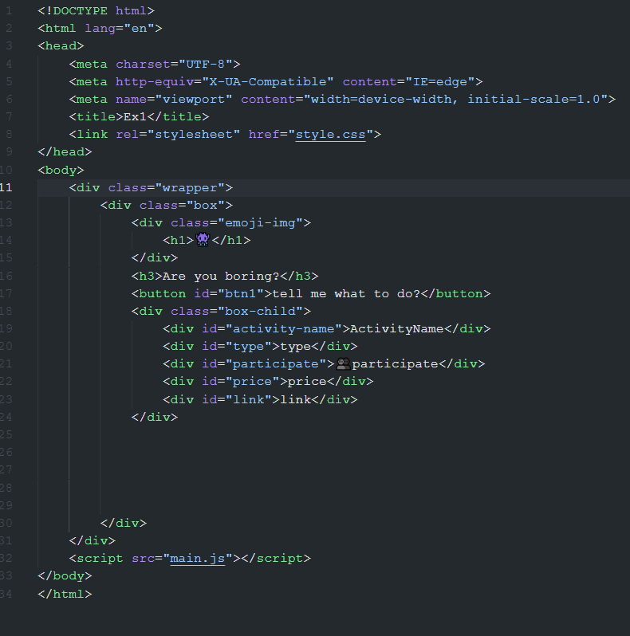

## SCSS:

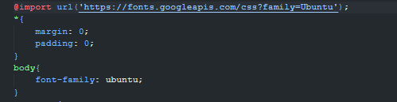

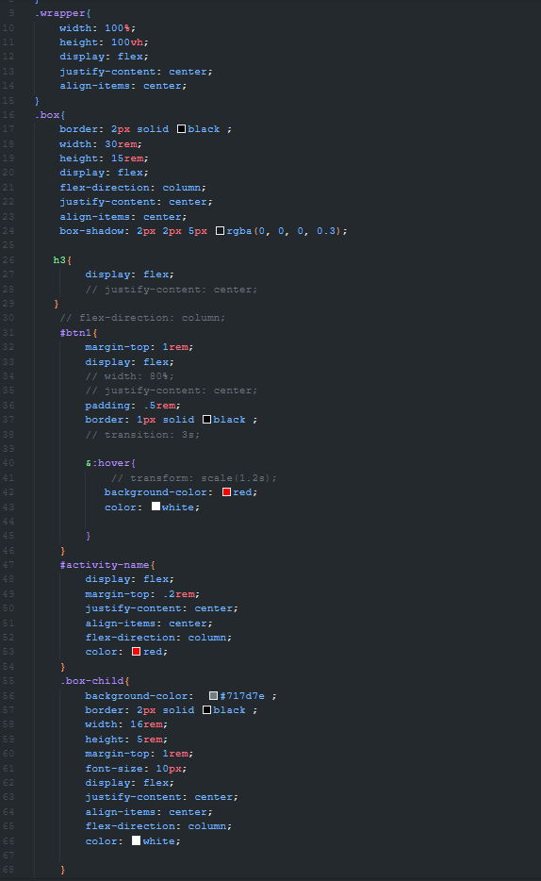

## JS:

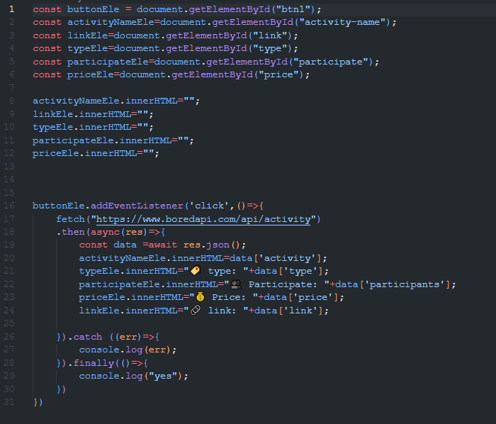

## Output:

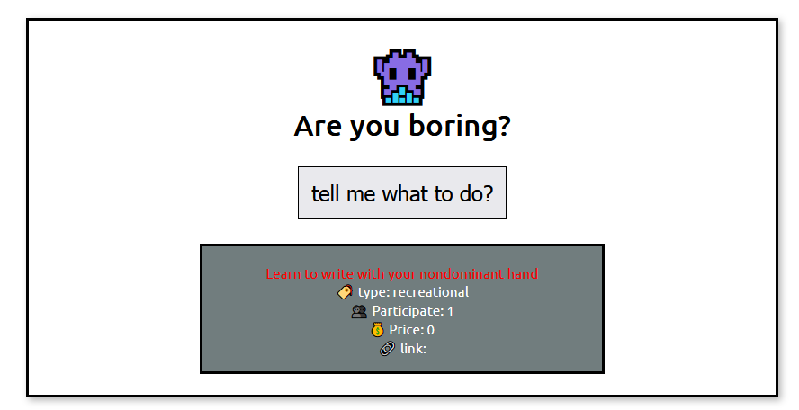

# TP05.2: Gender Guessing

## HTML:

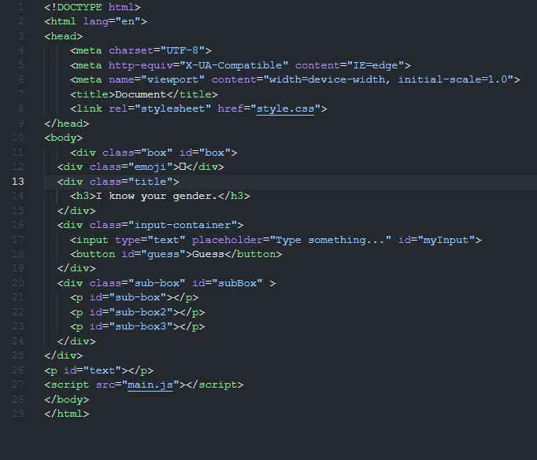

## SCSS:

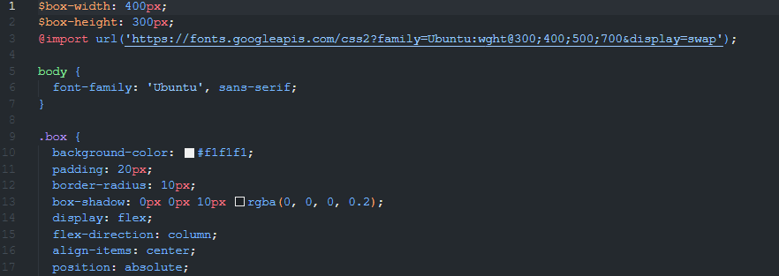

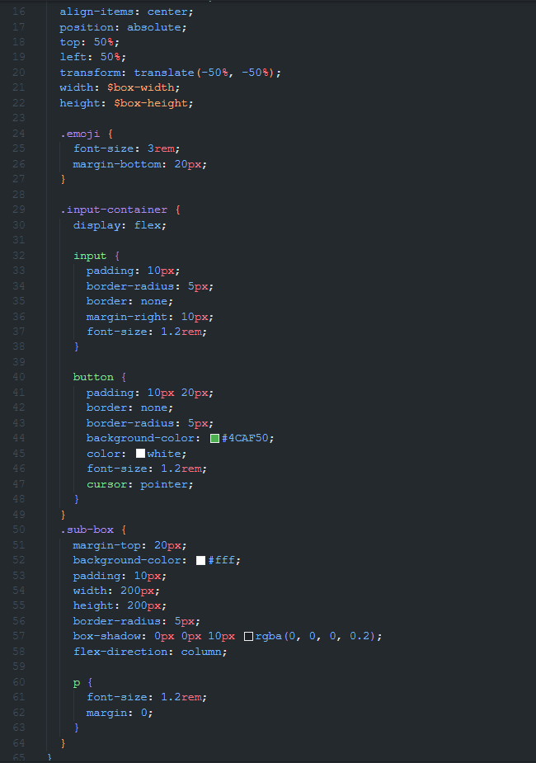

## JS:

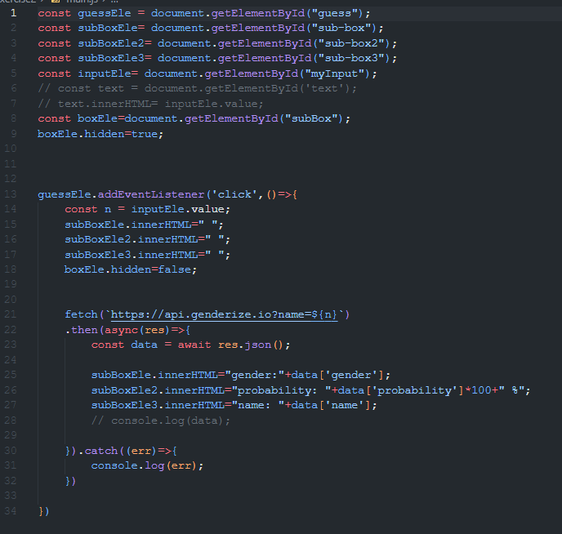

## Output:

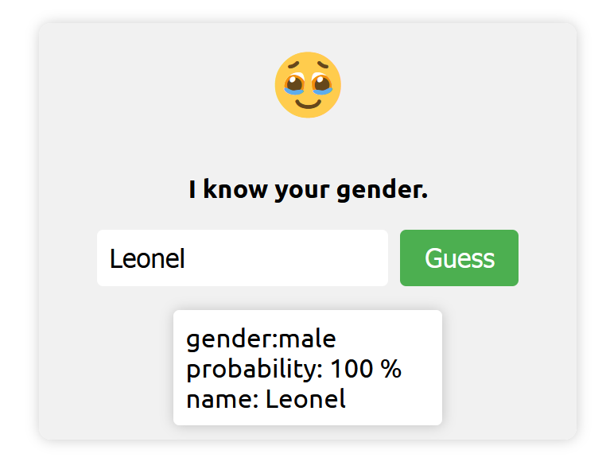

# TP05.3: Nationality Guessing

HTML:  
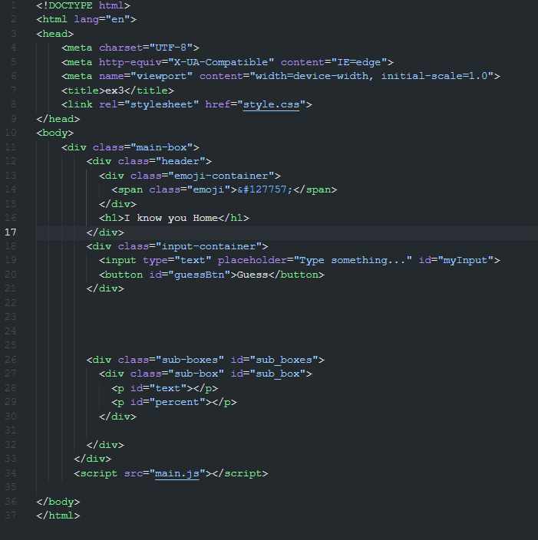

## SCSS:

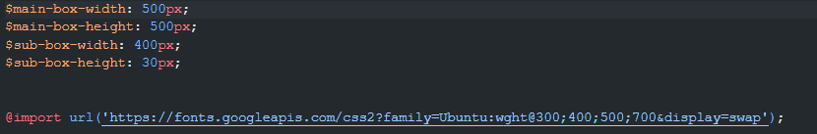

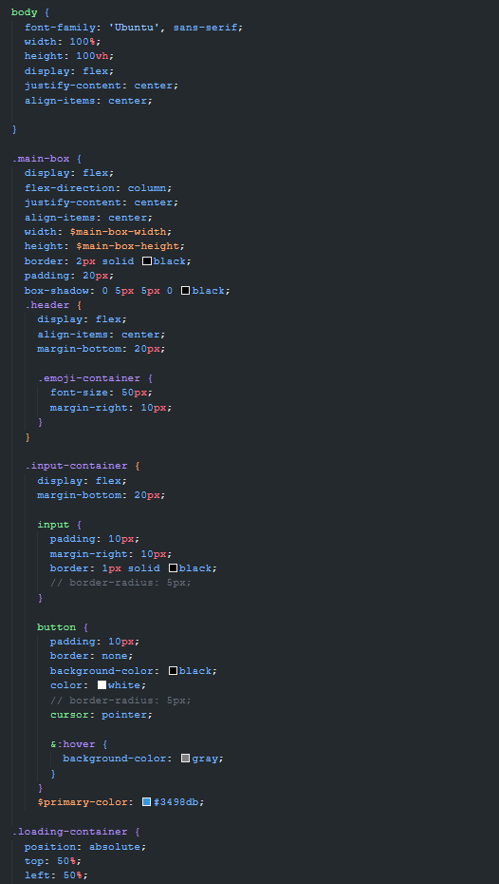

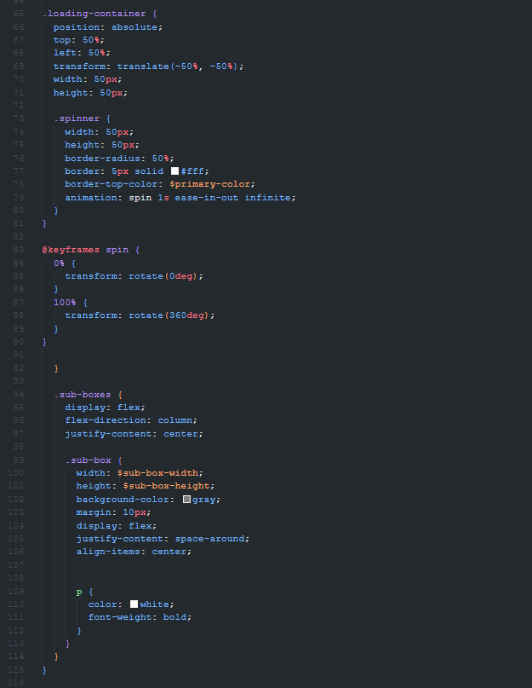

## JS:

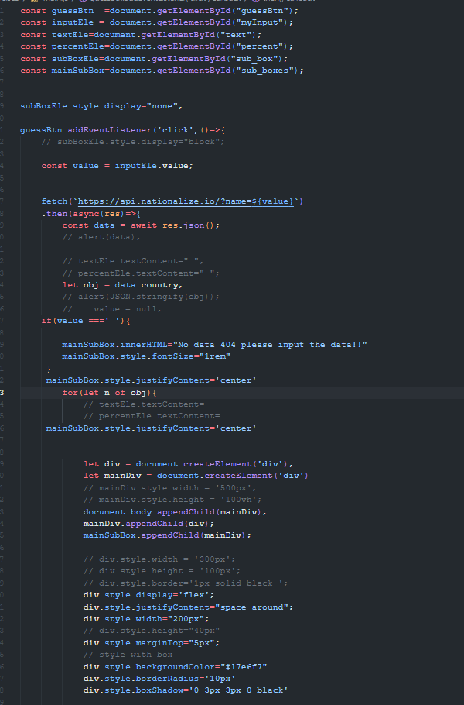

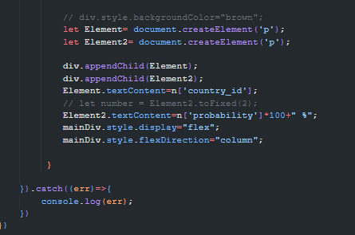

## Output:

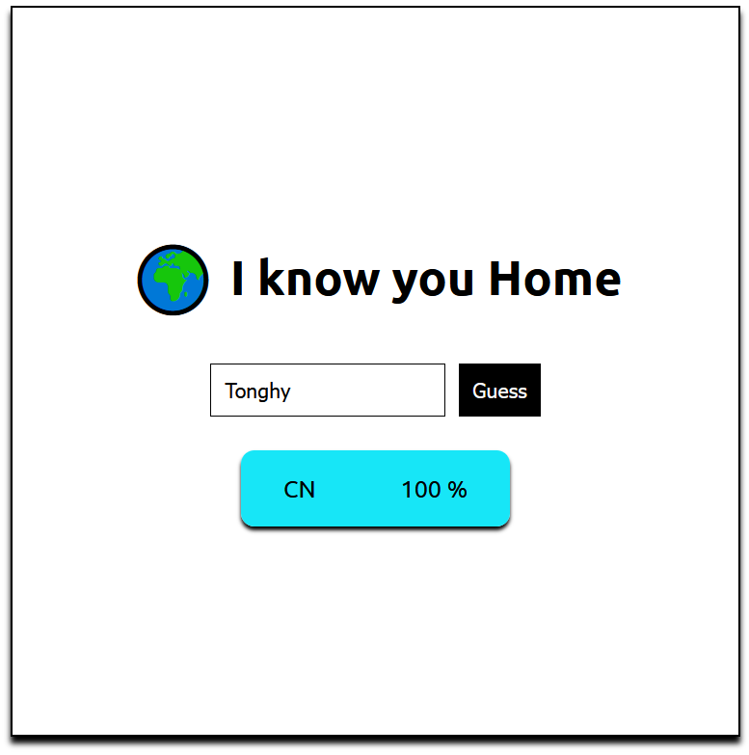

# TP05.4: University List

## HTML:

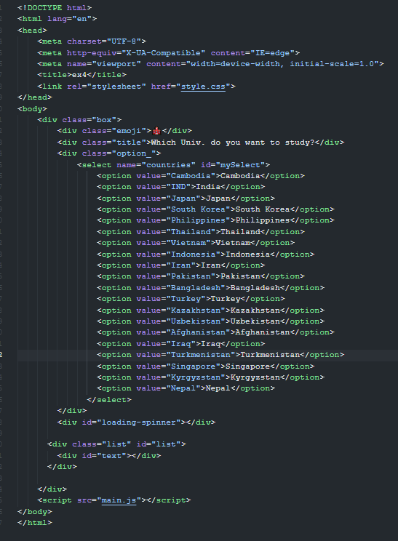

## SCSS

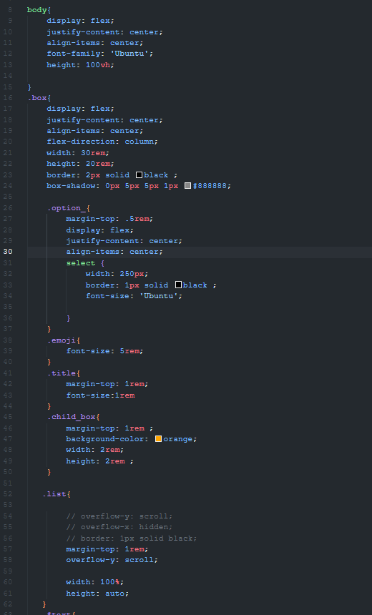

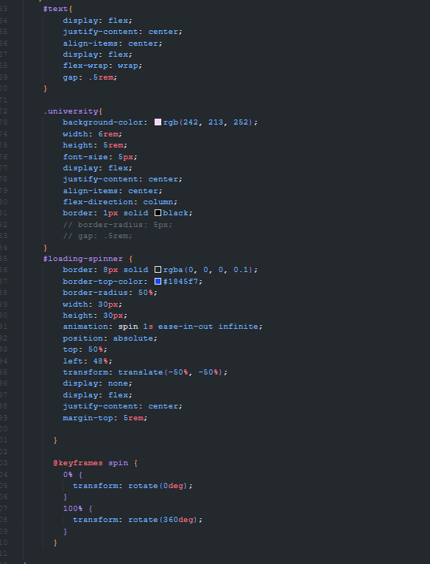

## JS:

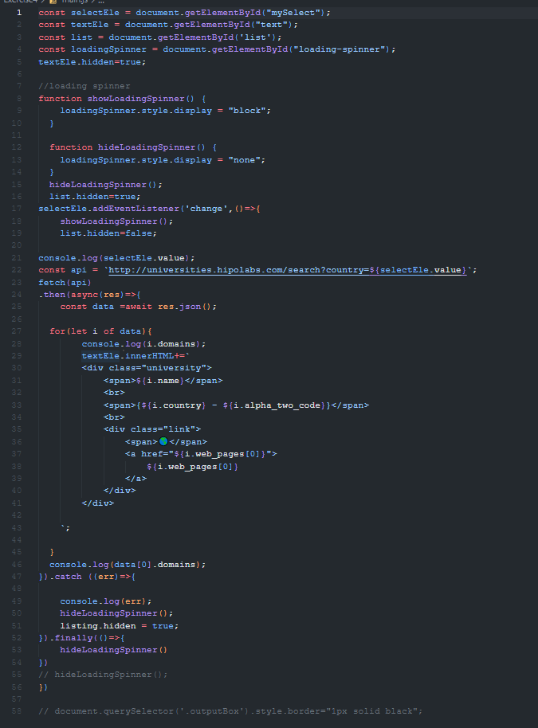

## Output:

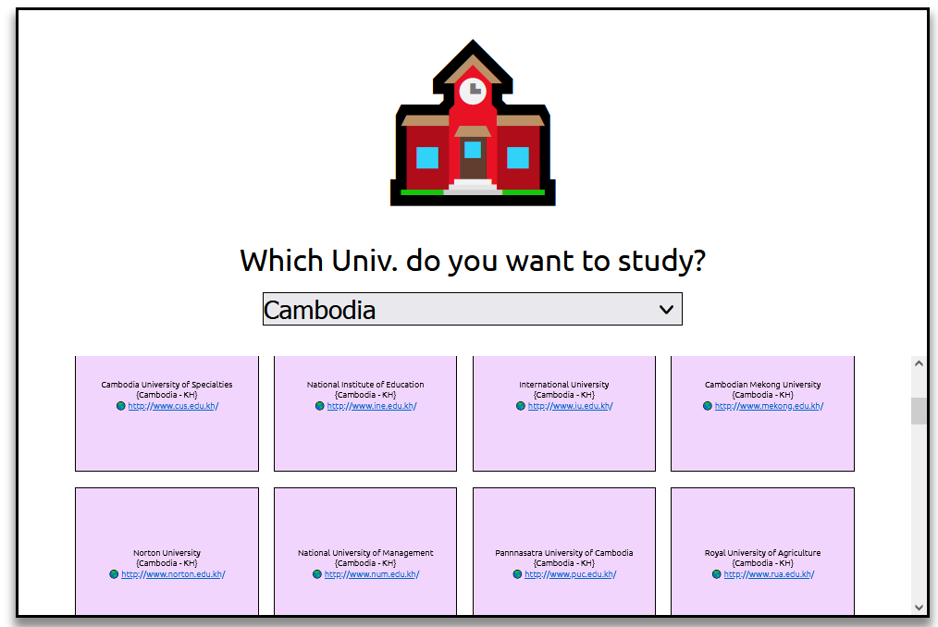

# TP05.5: Book Store

## Index.html :

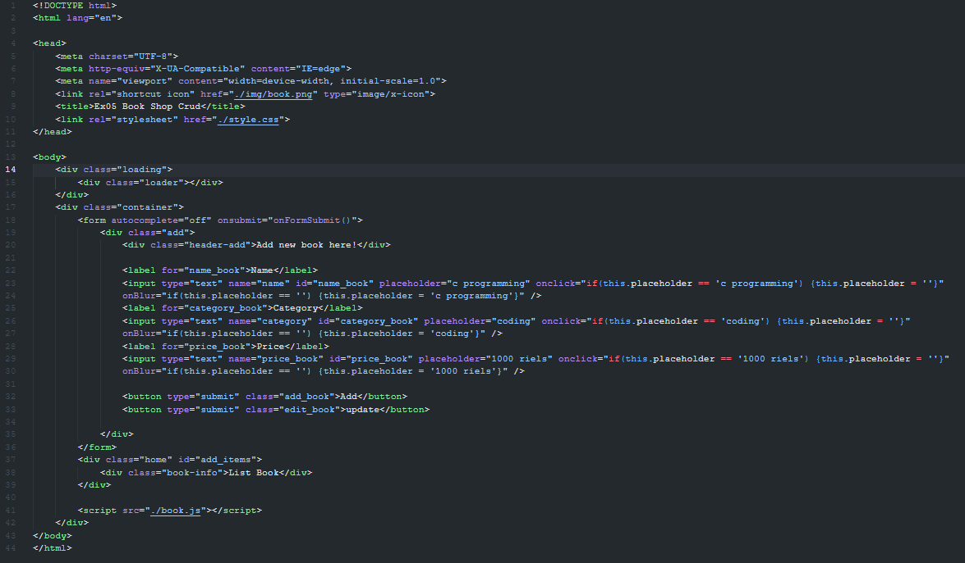

## Style.css:

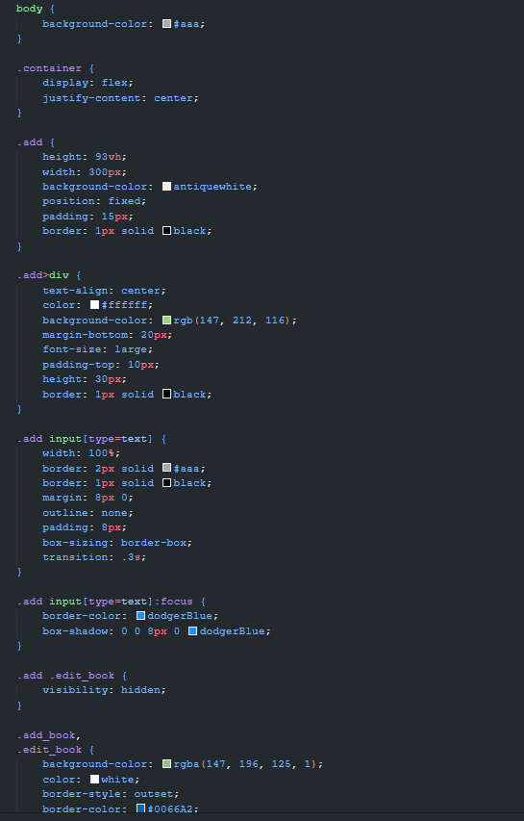

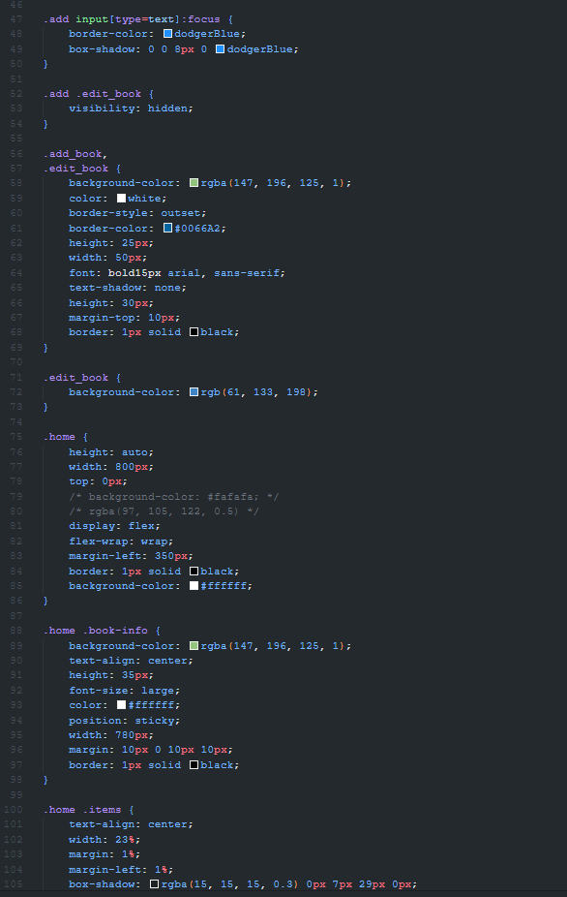

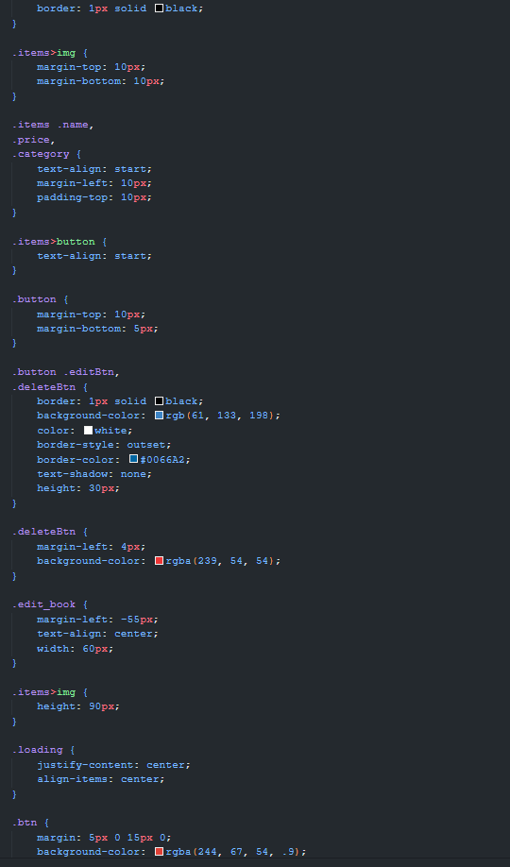

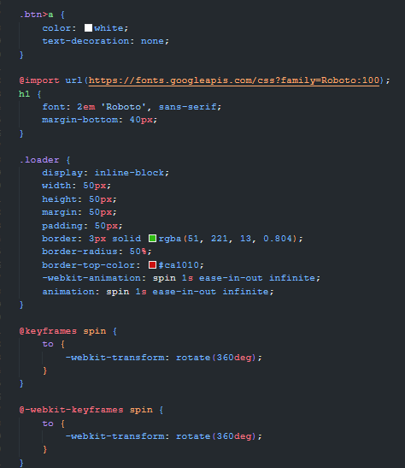

## Api-book.css:

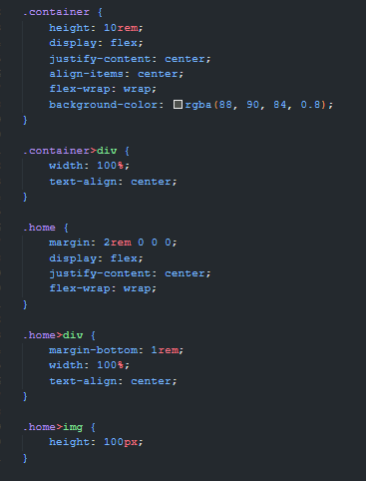

## Fetchapi-detail.html:

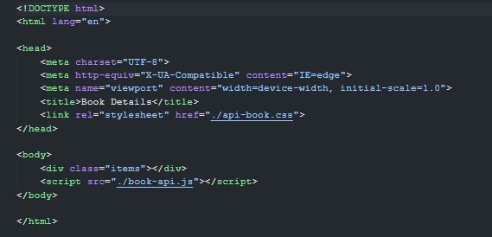

## Book.js :

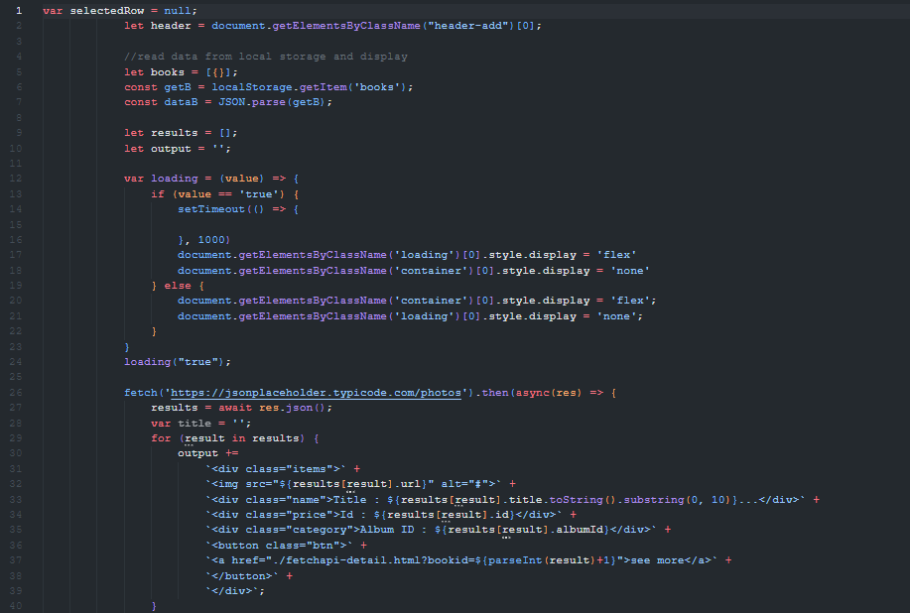

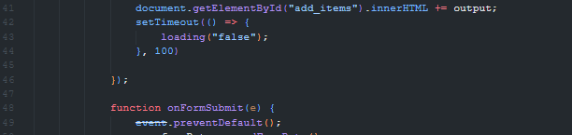

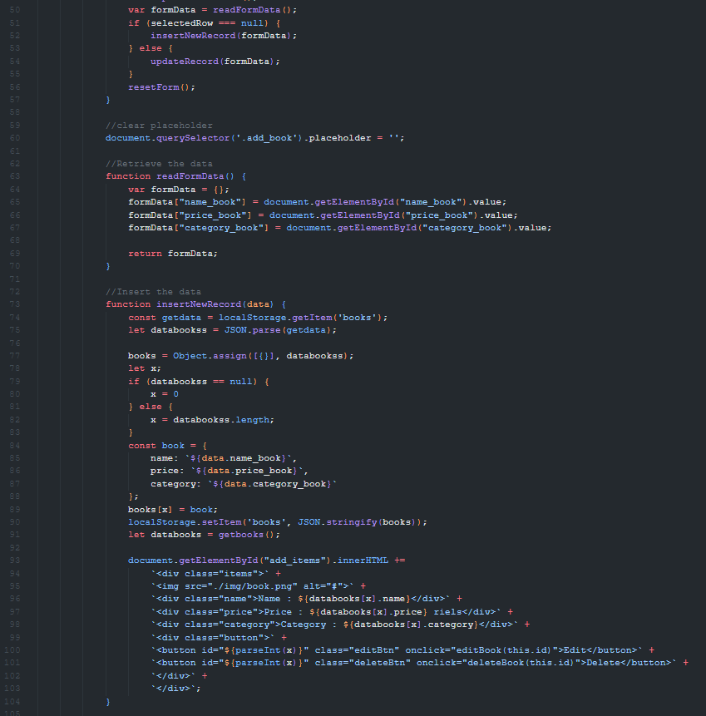

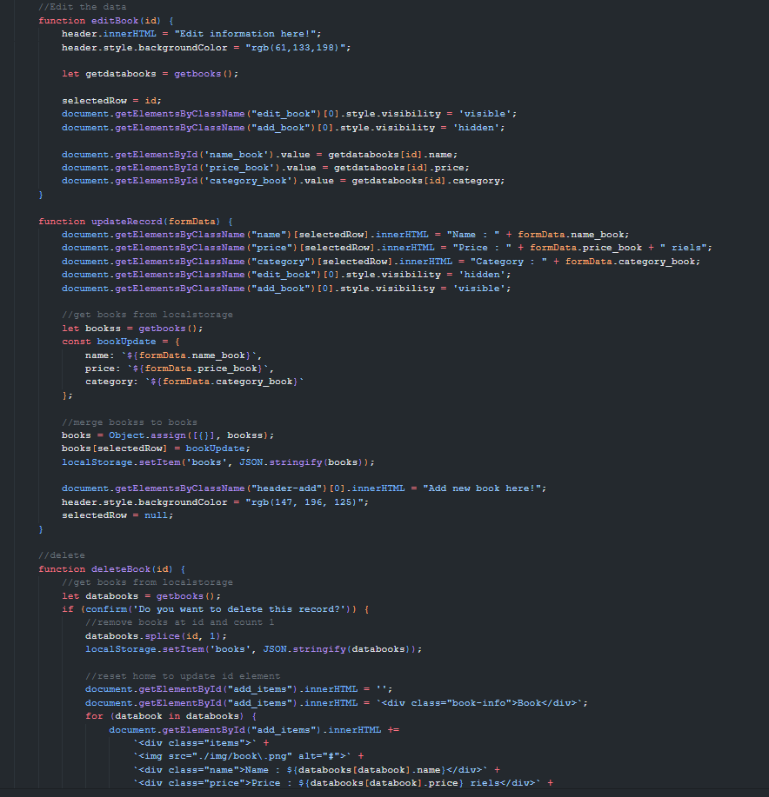

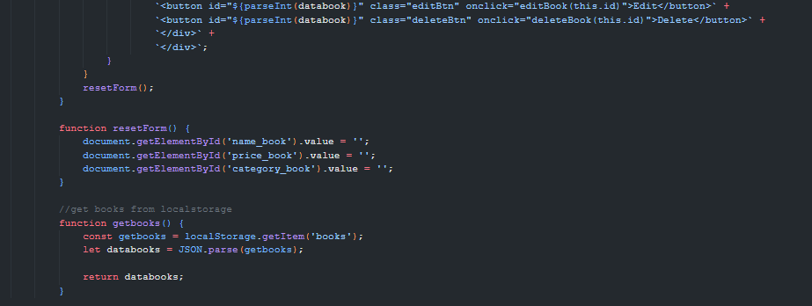

## Book-api.js:

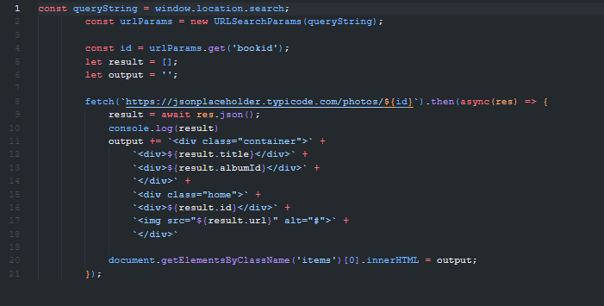

## Output:

## Home Output:

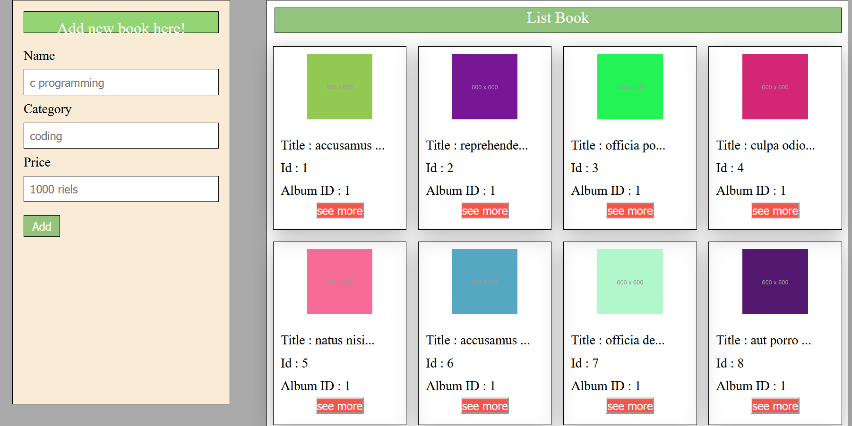

## Detail Page:

